Card Network
# Source: AI Source: Provided by: [Data Path: Persons Table -> ID Column: 1, Name_En Column: Motasem Essam] -> From: [ChatGPT] on [1/21/2026]
A Card Network Settlement System is a financial network that enables the clearing and settlement of transactions made using credit, debit, or prepaid cards. It connects issuing banks, acquiring banks, and merchants, ensuring that money is moved correctly after a card-based transaction is approved.

🧠 Simple Definition
# Source: AI Source: Provided by: [Data Path: Persons Table -> ID Column: 1, Name_En Column: Motasem Essam] -> From: [ChatGPT] on [1/21/2026]
A card network acts as the infrastructure that settles payments between the customer’s bank and the merchant’s bank after a card is used for a purchase.

🏛️ Popular Card Networks (That Also Handle Settlement)
# Source: AI Source: Provided by: [Data Path: Persons Table -> ID Column: 1, Name_En Column: Motasem Essam] -> From: [ChatGPT] on [1/21/2026]
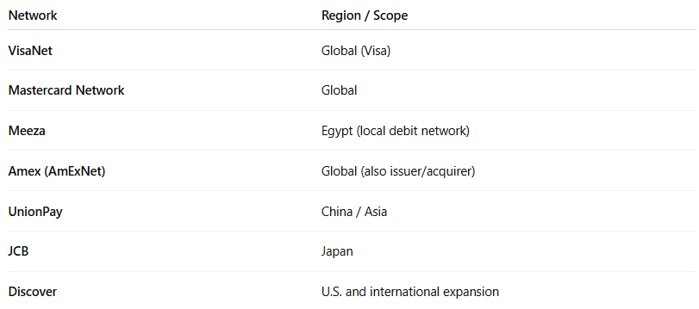

Network | Region / Scope
VisaNet | Global (Visa)
Mastercard Network | Global
Meeza | Egypt (local debit network)
Amex (AmExNet) | Global (also issuer/acquirer)
UnionPay | China / Asia
JCB | Japan
Discover | U.S. and international expansion

🔁 How Card Network Settlement Works
# Source: AI Source: Provided by: [Data Path: Persons Table -> ID Column: 1, Name_En Column: Motasem Essam] -> From: [ChatGPT] on [1/21/2026]
- Customer uses a card to pay for goods/services.
- The merchant's acquiring bank sends the request to the card network.
- The network routes the request to the issuing bank (payer’s bank).
- After authorization, the transaction is approved.
- Later, the card network settles the funds:
  - Moves money from issuing bank → acquiring bank.
  - Charges and distributes interchange, network, and processing fees.
🔐 Settlement usually occurs in batch mode, often T+1 or T+2 (1–2 business days later).

💡 What Card Networks Do During Settlement
# Source: AI Source: Provided by: [Data Path: Persons Table -> ID Column: 1, Name_En Column: Motasem Essam] -> From: [ChatGPT] on [1/21/2026]
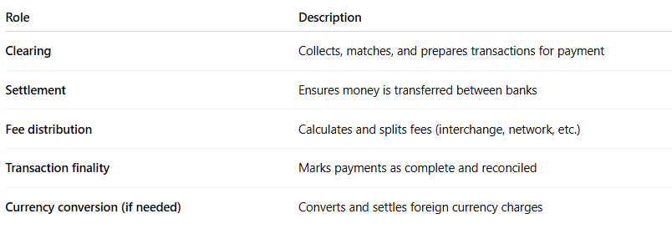
Role | Description
Clearing | Collects, matches, and prepares transactions for payment
Settlement | Ensures money is transferred between banks
Fee distribution | Calculates and splits fees (interchange, network, etc.)
Transaction finality | Marks payments as complete and reconciled
Currency conversion (if needed) | Converts and settles foreign currency charges

🔐 Security & Regulation
# Source: AI Source: Provided by: [Data Path: Persons Table -> ID Column: 1, Name_En Column: Motasem Essam] -> From: [ChatGPT] on [1/21/2026]
Card network settlements are:
- Highly regulated by global financial laws
- PCI-DSS compliant
- Monitored for fraud and chargebacks
- Subject to dispute resolution mechanisms between banks

📊 Settlement Timeline Example (Visa/Mastercard)
# Source: AI Source: Provided by: [Data Path: Persons Table -> ID Column: 1, Name_En Column: Motasem Essam] -> From: [ChatGPT] on [1/21/2026]
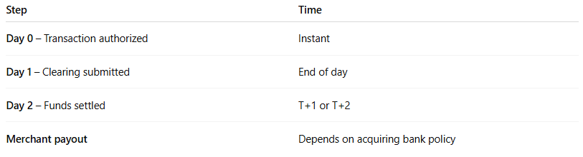

Step | Time
Day 0 – Transaction authorized | Instant
Day 1 – Clearing submitted | End of day
Day 2 – Funds settled | T+1 or T+2
Merchant payout | Depends on acquiring bank policy

📦 Benefits of Card Network Settlement
# Source: AI Source: Provided by: [Data Path: Persons Table -> ID Column: 1, Name_En Column: Motasem Essam] -> From: [ChatGPT] on [1/21/2026]
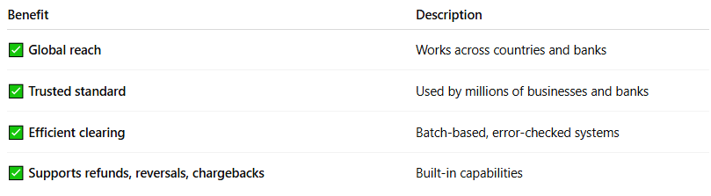

Benefit | Description
✅ Global reach | Works across countries and banks
✅ Trusted standard | Used by millions of businesses and banks
✅ Efficient clearing | Batch-based, error-checked systems
✅ Supports refunds, reversals, chargebacks | Built-in capabilities

🔄 Card Network vs Interbank Network
# Source: AI Source: Provided by: [Data Path: Persons Table -> ID Column: 1, Name_En Column: Motasem Essam] -> From: [ChatGPT] on [1/21/2026]
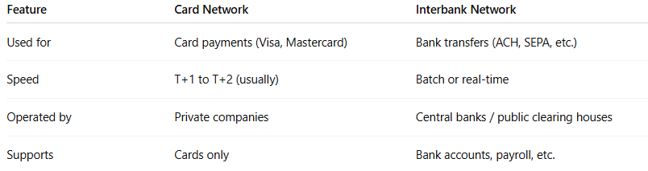

Feature | Card Network | Interbank Network
Used for | Card payments (Visa, Mastercard) | Bank transfers (ACH, SEPA, etc.)
Speed | T+1 to T+2 (usually) | Batch or real-time
Operated by | Private companies | Central banks / public clearing houses
Supports | Cards only | Bank accounts, payroll, etc.

🧠 Summary
# Source: AI Source: Provided by: [Data Path: Persons Table -> ID Column: 1, Name_En Column: Motasem Essam] -> From: [ChatGPT] on [1/21/2026]
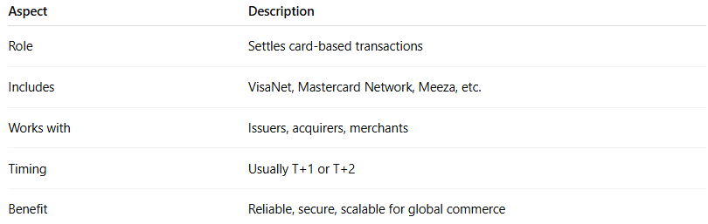

Aspect | Description
Role | Settles card-based transactions
Includes | VisaNet, Mastercard Network, Meeza, etc.
Works with | Issuers, acquirers, merchants
Timing | Usually T+1 or T+2
Benefit | Reliable, secure, scalable for global commerce

